Excel Test

- What is the purpose of a pivot table?
    - To perform a what-if analysis on a data table.
    - To compare data from different workbooks.
    - To merge different scenarios.
    - To highlight formula errors.
    - To summarize data in a three dimensional table.

- What will be the result of the formula in cell D1?
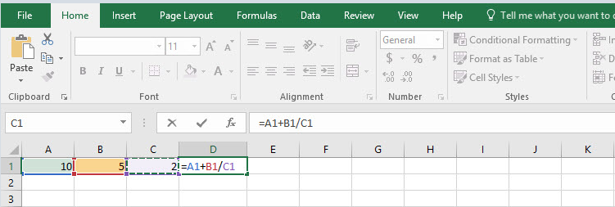
- Excel will display an error message and prompt the user to correct the formula
- #REF!
- 12.5
- #VALUE!
- 7.5

- I entered a date in cell B4 that I wish to replace with the value 10.5 (to be used in calculations) and have it display as “10.5” (without the quotes). How can I do this?
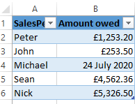
- I should change the number formatting of the cell.
- I simply enter 10.5 in the cell and the value will display correctly.
- I can only enter a date in cell B4, not any other type of value.
- I should type a space before entering the value 10.5.
- First I should delete the date with the Delete key.

- If I double-click on cell B6 in the above pivot table, what will be the result?

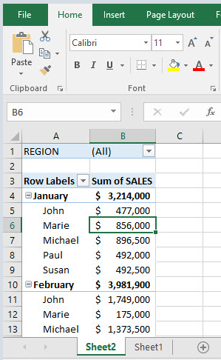
  - The Format Cells dialog box will display, enabling me to change the number format.
  - Row 6 will automatically be hidden
  - A new worksheet will be created with the breakdown of Marie's January sales.
  - The Value Field Settings dialog box will appear.
  - The source data worksheet will be displayed.

- The name Rate has been assigned to cell B1. Cell B4 contains the formula =$A4*Rate. If I copy this formula to cell C4, what will be the result?
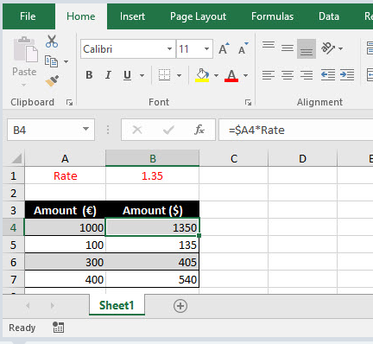

- a.135
- b.1822.5
- c.The error code #REF!.
- d.0
- e. 1350

- In what ways can I customize a sparkline? (multiple answers possible)

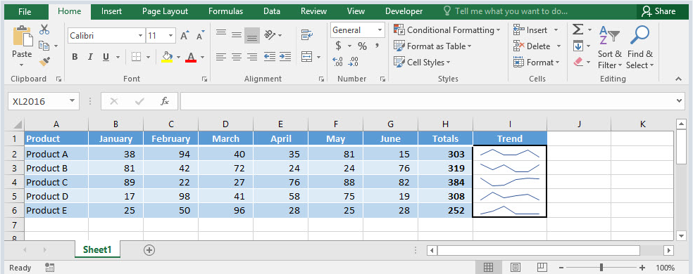

- I can control how empty or zero values are shown in the sparkline.
- I can display the highest value point in the data series.
- I can display the lowest value point in the data series.
- I can add data labels to the sparkline.
- A sparkline cannot be customized.

- Which function do you need to use to return the Day of the week e.g. Mon, Tue, Wed..

- What does INDEX and MATCH do

- What is a slicer?

- What are the key PivotTable 'sections' into which users can drag columns?

